Practical - 6
Practical Title: 6: Rendering External JSON Data using Fetch API, Search and Filter

Problem Definition: Display event lists, student profiles, notices, or FAQs from external JSON files using Fetch API. Implement dynamic rendering, search, filter, sorting, and pagination.

A. Theory
1. How is JSON fetched, parsed, and rendered?
ANSWER:
- Fetching: The fetch() API is used to request data from an external JSON file such as events.json or students.json.
- Parsing: The response is converted into JavaScript data using the .json() method.
- Rendering: The parsed array of objects is processed using JavaScript array methods and displayed dynamically in the HTML page.
- The general flow is:
JSON file → fetch() → .json() → JavaScript array → Search/Filter/Sort → HTML rendering

2. Which array methods are used for search, filter, sort, and pagination?
ANSWER:
The filter() method is used to select records according to a particular condition, while find() can be used to search for a specific record. The sort() method is used to arrange records in ascending or descending order. The slice() method is useful for implementing pagination by selecting a specific range of records. The forEach() method is used to iterate through the records and display them dynamically on the webpage.

3. How are loading and error states handled?
ANSWER:
A loading message is displayed while the JSON data is being fetched from the external file. After the data is successfully loaded, the loading message is replaced with the actual records. Errors are handled using .catch() or try-catch, which displays an appropriate error message if the JSON file cannot be loaded, the file path is incorrect, or some other fetching or parsing error occurs. This improves the reliability and user experience of the web application.

4. How is modularity maintained in JavaScript files?
ANSWER:
Modularity is maintained by dividing the JavaScript program into separate functions, where each function performs a specific task. For example, separate functions can be created for fetching data, rendering records, searching, filtering, sorting, and pagination. This makes the code easier to understand, debug, test, and maintain. It also allows the same functions to be reused with different JSON datasets.

Implementation/ Output/Result:

Evidence of Work (Screenshots):

By entering name, student profile loaded successfully:
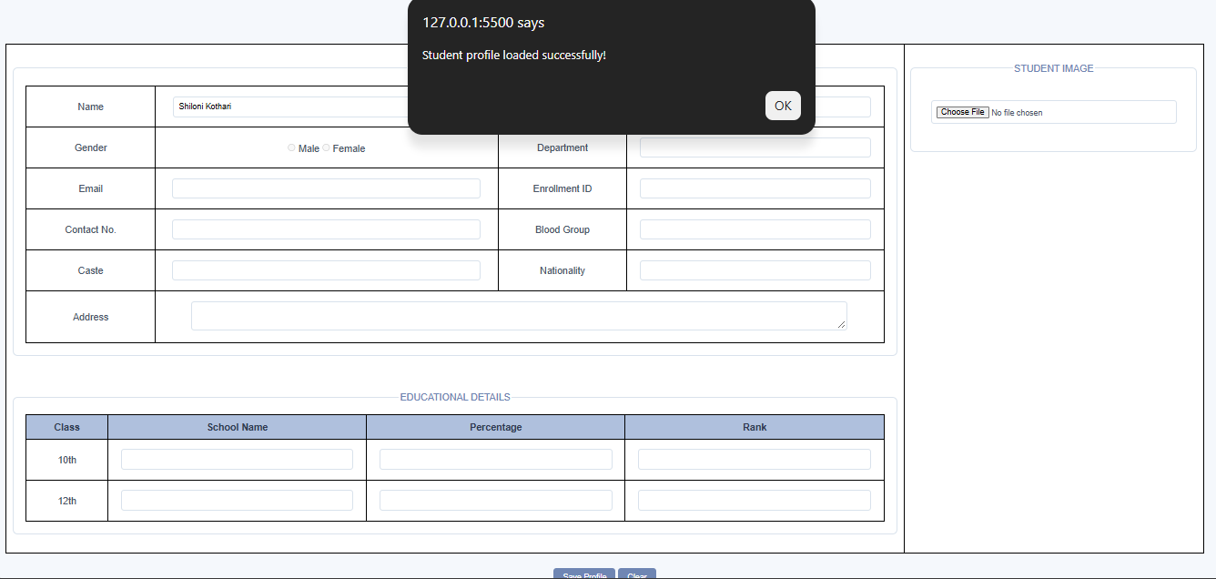

The details fetched successfully:
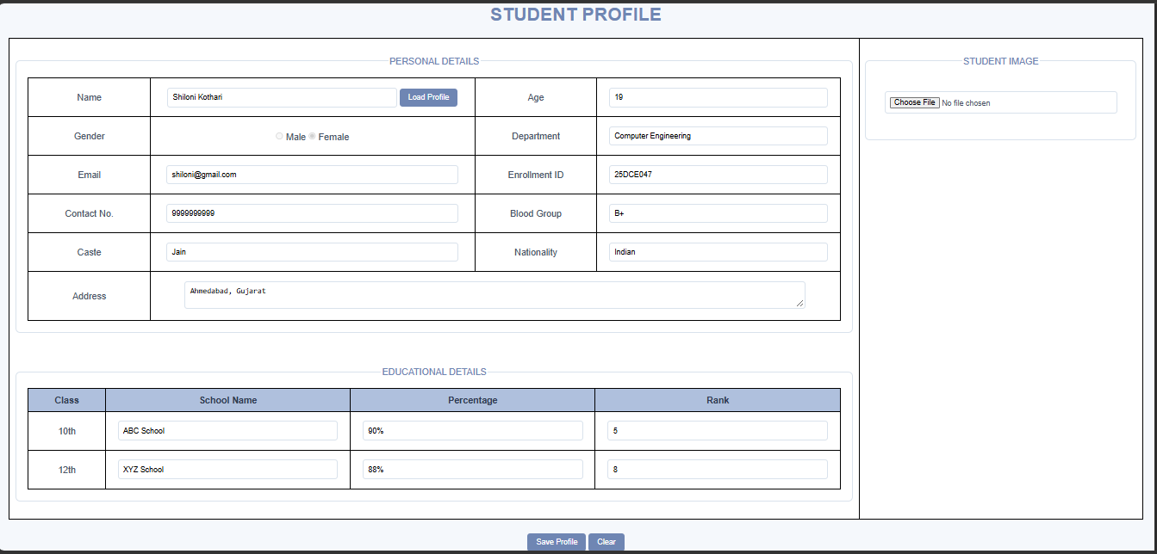

GitHub Repository Link:
- https://github.com/princemerja2/WDF/tree/main/Practical-6

E.Challenges Faced:

- First when fetched data it showed error:
(due to fetch path not given properly.)
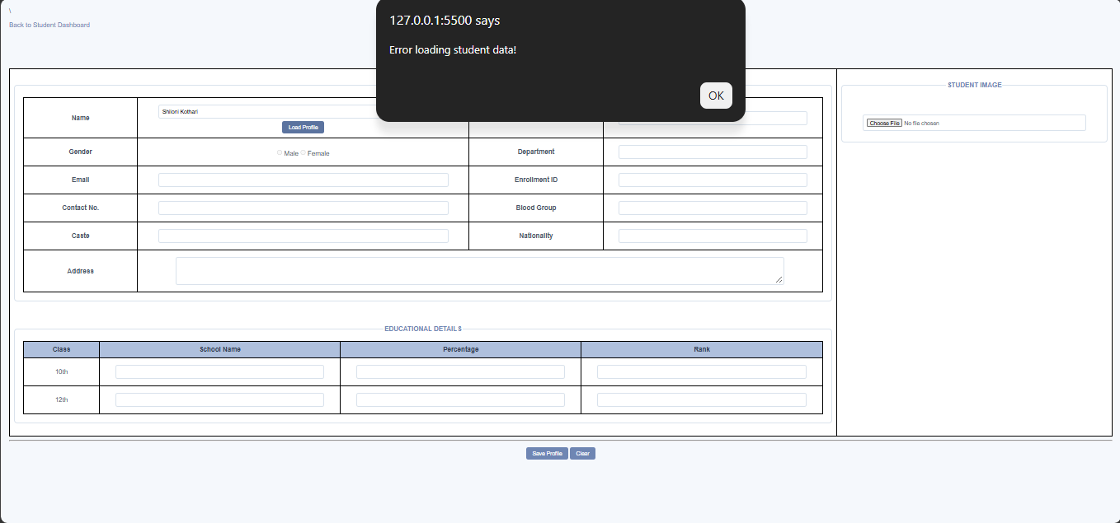

- Handling cases where the JSON file could not be loaded or contained incorrect data was another challenge.
- Making the search work for both uppercase and lowercase user input required converting the text into a common case.

F.Learning Outcomes:
- Understanding how to use the Fetch API to retrieve data from an external JSON file.
- To handle loading and error states in a web.
- To understand how external JSON data can be used in real-world applications such as student portals, event management systems, notices, and FAQ pages.
- learned how to perform case-insensitive searching in a dataset.
- Learned how to test a web application using different inputs and edge cases.

Faculty Remarks:

